Walk Off Sponsor
A Walk Off Sponsor supports the league through field and structure improvements for three (3) years at a level of $6000.00. The benefits include:
- Opportunity to have your business name and logo displayed on one of our scoreboards
- A vinyl banner with your business information will be displayed in front of the Home and Away dugouts on a field of your choosing.
- Your business name will be prominently displayed on a professionally prepared 4’ x 8’ sign located as part of our Field #1 Sponsor Wall or attached to the Field #1 Bleachers (as space permits). This sign will include your business name with logo and phone number and be displayed for each year of sponsorship at our Alderwood Little League Play Fields. Note: The sponsor will provide all logo(s), artwork and verify the correct name/phone number before the sign is printed. Over 400 players and their families visit our fields each week of the season!
- Your business logo and link to your website will be recognized on our social media pages.
- Your business will be offered an opportunity to distribute information and/or coupons related to your business during select Alderwood Little League events.
- Your business name and/or logo will be displayed on a professionally prepared 3’ x 4’ vinyl banner. This banner will be posted on the outfield fence of your choosing.
- Your business logo with link will be prominently displayed on the official League website with recognition as a Walk Off Sponsor. Our website is the #1 source of information about Alderwood Little League!
- Each year your business will receive a Sponsor Plaque with a team photo.
Grand Slam Sponsor
A Grand Slam Sponsor supports a team in the Major or Junior League Divisions of Baseball or Softball for three (3) years at a level of $3000.00. The benefits include:
- Your business name will be prominently displayed on a professionally prepared 4’ x 8’ sign located as part of our Field #1 Sponsor Wall or attached to the Field #1 Bleachers (as space permits). This sign will include your business name with logo and phone number and be displayed for each year of sponsorship at our Alderwood Little League Play Fields. Note: The sponsor will provide all logo(s), artwork and verify the correct name/phone number before the sign is printed. Over 400 players and their families visit our fields each week of the season!
- Your business logo and link to your website will be recognized on our social media pages.
- Your business will be offered an opportunity to distribute information and/or coupons related to your business during select Alderwood Little League events.
- Your business name and/or logo will be prominently displayed on a professionally prepared 3’ x 4’ vinyl banner. This banner will be posted on the outfield fence of your choosing.
- Your business name will be displayed on the team jersey. Many of our teams travel throughout Snohomish County providing additional marketing for your business!
- Your business logo with link will be prominently displayed on the official League website with recognition as a Grand Slam Sponsor. Our website is the #1 source of information about Alderwood Little League!
- Each year your business will receive a Sponsor Plaque with a team photo.
Home Run Sponsor
A Home Run Sponsor supports a team in the Minor League Divisions of Baseball or Softball for one (1) year at a level of $2000.00. Sponsors renewing their Home Run Sponsorship and do not require a new banner will incur a renewal fee of $1000.00 per year. (There is a maximum of two (2) yearly renewals.) The benefits include:
- Your business logo and link to your website will be recognized on our social media pages.
- Your business will be offered an opportunity to distribute information and/or coupons related to your business during select Alderwood Little League events.
- Your business name and/or logo will be prominently displayed on a professionally prepared 3’ x 4’ vinyl banner. This banner will be posted on the outfield fence of your choosing.
- Your business name will be displayed on the team jersey. Many of our teams travel throughout Snohomish County providing additional marketing for your business!
- Your business logo with link will be prominently displayed on the official League website with recognition as a Home Run Sponsor. Our website is the #1 source of information about Alderwood Little League!
- Each year your business will receive a Sponsor Plaque with a team photo.

Double Play Sponsor
A Double Play Sponsor supports one team in the Minor or T-Ball Divisions of Baseball or Softball for one (1) year at a level of $1000.00. Sponsors renewing their Double Play Sponsorship and do not require a new banner will incur a renewal fee of $500.00 per year. (There is a maximum of two (2) yearly renewals.) Benefits to your business include:
- Your business name and/or logo will be prominently displayed on a professionally prepared 3’ x 4’ vinyl banner. This banner will be posted on the outfield fence of your choosing.
- Your business name will be displayed on the team jersey. Many of our teams travel throughout Snohomish County providing additional marketing for your business!
- Your business logo with link will be prominently displayed on the official League website with recognition as a Double Play Sponsor. Our website is the #1 source of information about Alderwood Little League!
- Each year your business will receive a Sponsor Plaque with a team photo.
Base Hit Sponsor
A Base Hit Sponsor supports the general Alderwood Little League General Fund (equipment, maintenance, repairs, etc) at a level of $300.00 for one (1) year. Benefits to your business include:
- Your business logo with link will be- prominently displayed on the official League website with recognition as a Base Hit Sponsor. Our website is the #1 source of information about Alderwood Little League!
- Each year your business will receive a Sponsor Plaque with a team photo.

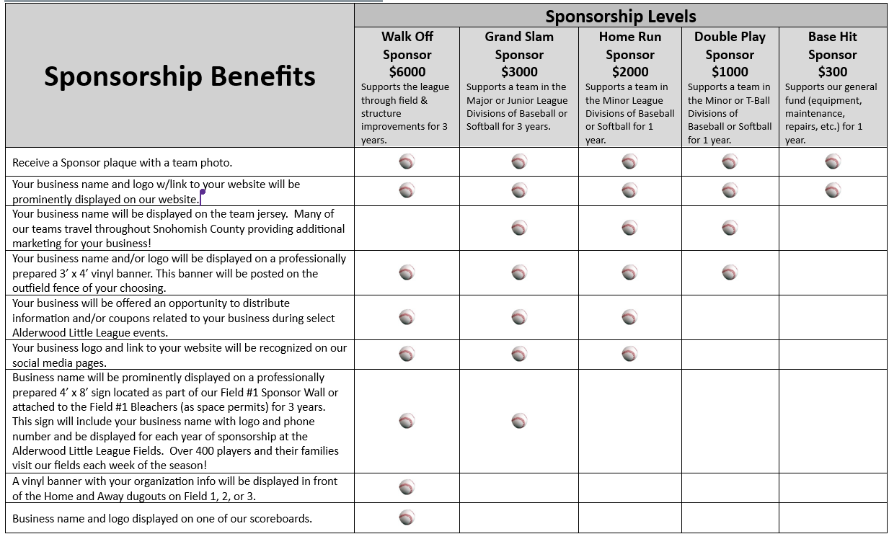

Sponsorship Agreement
This agreement between Alderwood Little League (hereinafter “Local Little League”) and (hereinafter “Sponsor”) is for the season(s).
Sponsorship of a team in the Local Little League must be, for the Sponsor, out of a sense of duty to help the community. While sponsorship does afford some benefits (detailed below), the higher purpose is to help the Local Little League impart the value of teamwork, sportsmanship, and fair play to the children of the community, so that they may someday use these values in becoming good citizens.
Sponsorship of a team in the Local Little League does not permit the Sponsor to have any rights or responsibilities in the operation of the Local Little League or any team in the Local Little League, nor does the Sponsor have any rights or responsibilities in the selection of managers, coaches or players for any team in the Local Little League. Nothing herein shall make us partners or joint ventures. The Sponsor and the Local Little League are independent contractors with respect to one another, and neither shall have any authority to represent or bind the other in any manner or to any extent whatsoever, except as specified herein.
The Sponsor shall have the right to use the following term in advertisements, posters, brochures, newsletters, etc.: “Sponsor of a team in the Alderwood Little League”. Sponsorship does NOT give the Sponsor the right to use the word “official” in connection with its sponsorship. Any reference to the Sponsorship under this agreement must make it clear that the Sponsorship is with a team or teams in the Local Little League only, and NOT for Little League Baseball. Use of the “keystone logo” or any other logo of Little League Baseball is prohibited, unless permission is expressly granted in writing by Little League Baseball International.
For the considerations above, the Sponsor chooses the donation level below to support the Local Little League, understanding that its donation is to benefit the entire league.
 | Sponsor Level (check one) | Sponsorship Commitment (circle one) | Amount
 | Walk Off Sponsor
 | Grand Slam Sponsor | Major BB Major SB Junior BB
 | Home Run Sponsor (New) | Minor BB Minor SB
 | Home Run Sponsor (Renewal) | Minor BB Minor SB
 | Double Play Sponsor (New) | T-Ball Minor BB Minor SB
 | Double Play Sponsor (Renewal) | T-Ball Minor BB Minor SB
 | Base Hit Sponsor
 | Other
AGREED and ACCEPTED this ____ Day of _________________ 20____.
Contact Name: Contact Signature:
(Print Name clearly)
Contact Phone: Contact Email:
The following sponsor information will be used for the website: Email Company Logo to sponsors@alderwoodlittleleague.com
Sponsor Name:
(Print Name clearly)
Sponsor Address: _________________________________________________________________________________________
(Street) (City, State) (Zip code)
_________________________ ___________________________________________ ____________________________________
Sponsor Phone Sponsor Email Sponsor Website Address

Please make checks payable to: Please mail check and completed form to:
“Alderwood Little League” Alderwood Little League
Attention: Sponsorship Coordinator
P.O. Box 3326
Lynnwood, WA 98046-3326

